# Static Testing

## What is Static Testing

**# Source**: **Chatgpt (GPT-5-Standard) at [8/14/2025]**

**Static Testing** is a type of software testing where the software is **examined without actually executing the code**.  
 Instead of running the program, you review and analyze **documents, code, and design** to find defects early in the development lifecycle.

## **Key Points**

**# Source**: **Chatgpt (GPT-5-Standard) at [8/14/2025]**

* **Goal:** Detect errors, inconsistencies, or deviations from requirements before running the software.
* **When:** Performed in the early phases of the Software Development Life Cycle (SDLC).
* **How:** Through **reviews, walkthroughs, inspections**, and static analysis tools.
* **Cost Benefit:** Defects found here are cheaper to fix than those found after execution.

## **Types of Static Testing**

**# Source**: **Chatgpt (GPT-5-Standard) at [8/14/2025]**

1. **Manual Static Testing**
   * **Reviews** (informal checking)
   * **Walkthroughs** (author explains content to peers)
   * **Inspections** (formal, checklist-based defect finding)
2. **Automated Static Testing**
   * Static code analysis using tools (e.g., SonarQube, ESLint, PMD)
   * Automated scans for security vulnerabilities, code smells, or unused variables.

## **Examples**

**# Source**: **Chatgpt (GPT-5-Standard) at [8/14/2025]**

* Reviewing **requirements documents** to check for ambiguity.
* Checking **test cases** for coverage and correctness before execution.
* Analyzing **source code** for:  
  + Unused variables
  + Syntax violations
  + Potential security flaws (e.g., SQL injection risks)
* Verifying **design documents** against architecture standards.

## **Static vs. Dynamic Testing**

**# Source**: **Chatgpt (GPT-5-Standard) at [8/14/2025]**

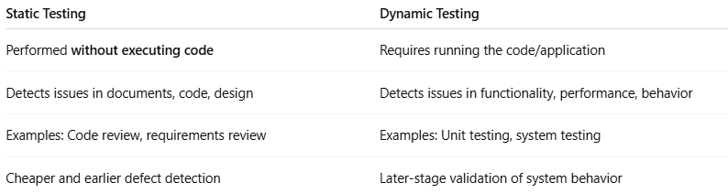

|  |  |
| --- | --- |
| **Static Testing** | **Dynamic Testing** |
| Performed **without executing code** | Requires running the code/application |
| Detects issues in documents, code, design | Detects issues in functionality, performance, behavior |
| Examples: Code review, requirements review | Examples: Unit testing, system testing |
| Cheaper and earlier defect detection | Later-stage validation of system behavior |

💡 **In short:** Static testing is like proofreading a book before it’s printed, while dynamic testing is like reading the book aloud to see if the story works.